Step 1– Install Eclipse IDE

Step 2-Install JAVA

Step 3- Configure Eclipse IDE with jar files .

Step 4- Intall **TestNg plugin** from Eclipse MarketPalce.

Step 5- creat a java project.

Step 6- Configure TestNg by RightClick on project-Build Path - Add Library-select TestNg-Next -Apply and close

Step 7- Install Firefox webBroser

Step 8 – Copy and paste the Rc folder to the project from the Assignment folder (From GitHub download).

Step 9- Copy the SRC files and paste in the project.

Step -10-Go to RC folder – RightClick On geccodriver.exe - go to Properties- Copy the location – Paste in the program in highlighted areas ..

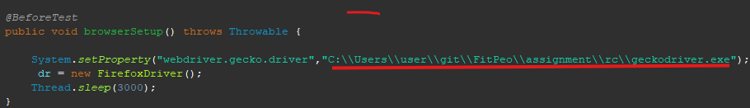



Step 11- Run the program.